Week 1 – Python Essentials + AI Fundamentals

Day 2 – Collections and Control Flow

Collections
Python has 4 commonly used collections type.

- List: Ordered and Changeable. This is same as ArrayList in Java.

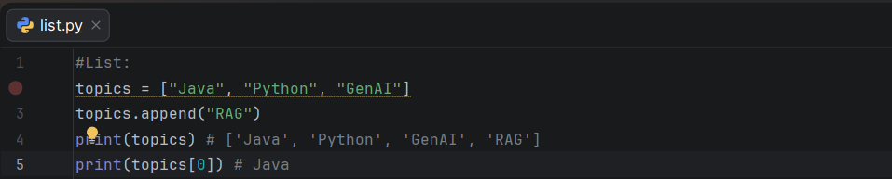

- Tuple: Ordered and Immutable.

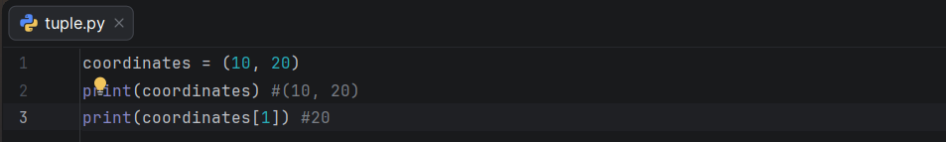

- Set: Unique elements. It does not guarantee the display order

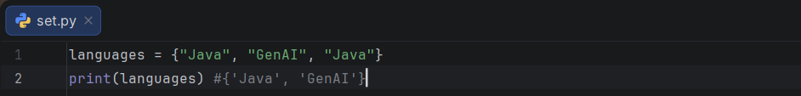

- Dictionary: Key-value pair. It is same as HashMap in Java where keys are unique.

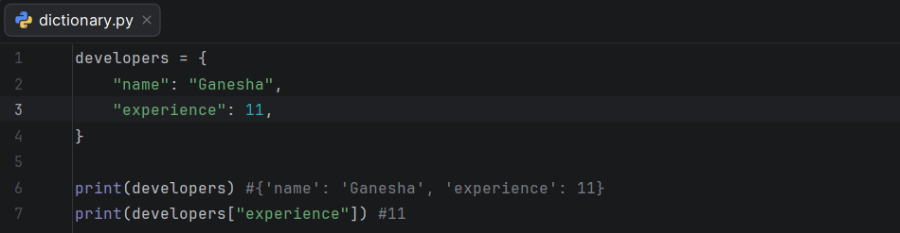

Common Collection Operations

List:
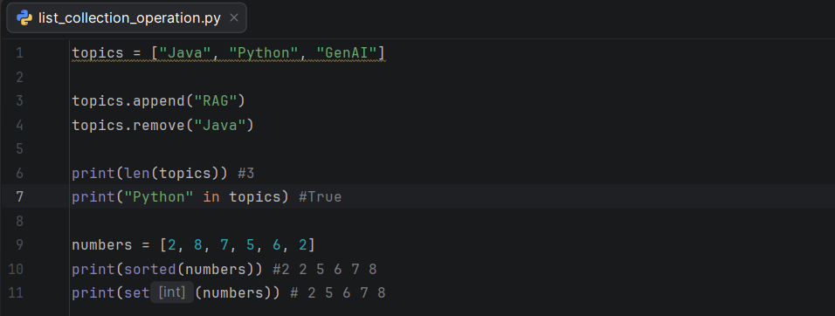

Dictionary:
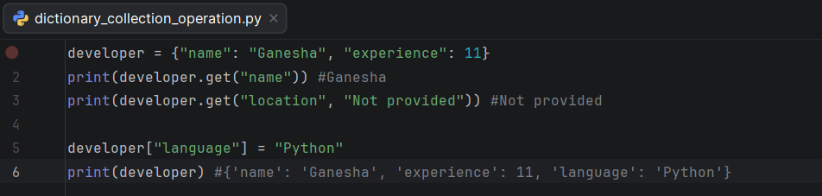

The break and continue statement
The break statement stops the loop and continue statement skips the current iteration.

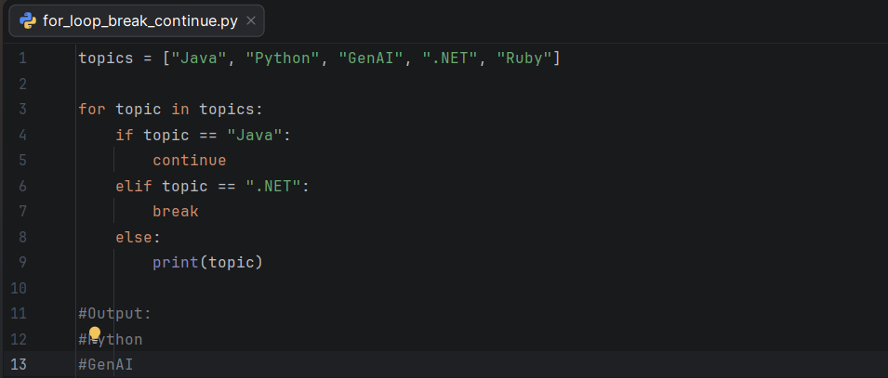

range: Generate number from 1 to 4.

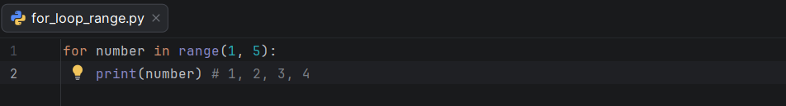

List Comprehension

A comprehension creates a collection in a concise way.

Traditional & Comprehension Approach:

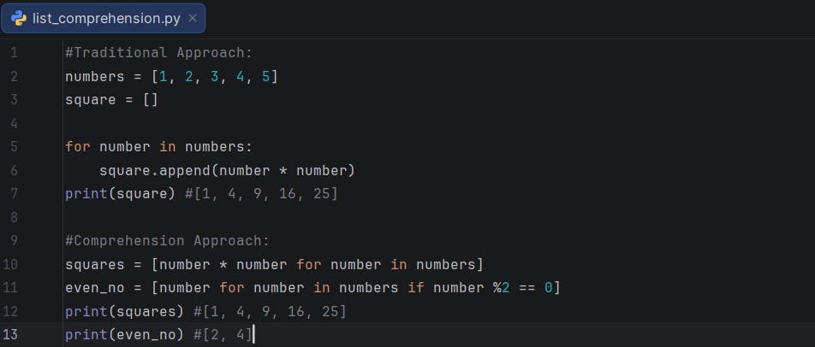

Dictionary Comprehension

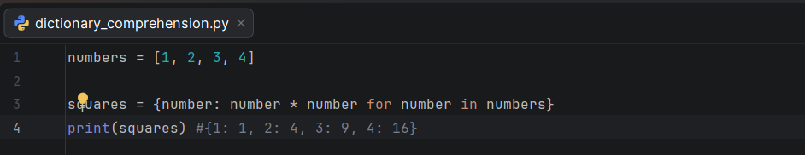

Learn to read a text file

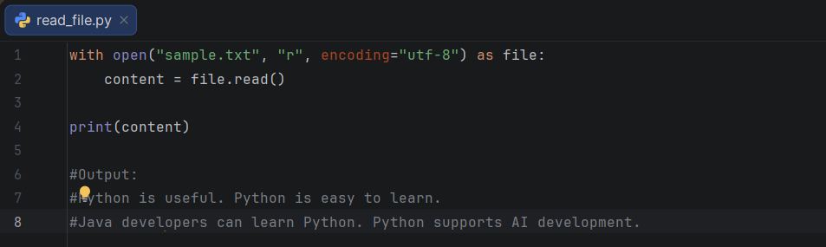

Assignment 1: Remove Duplicates
Given ["Java", "Python", "Java", "GenAI", "Python"], produce a collection containing only unique values.

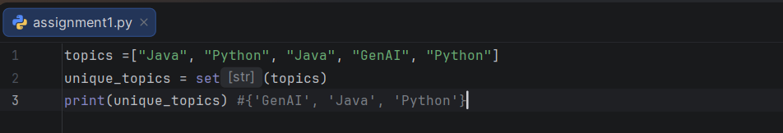

Assignment 2: Find Common Elements
Given two lists of programming languages, use sets to find which languages appear in both.

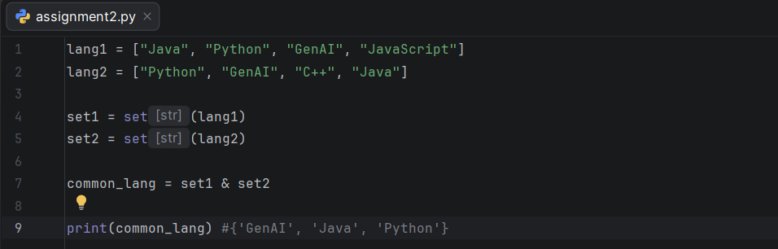
Assignment 3: Student marks
Create a dictionary of student names and marks. Print students who scored 70 or above, using safe dictionary access where appropriate.

